Step by Step plan for adding new administration.

- If the details are missing, fill out the Admin Info section for the newly imported admin.
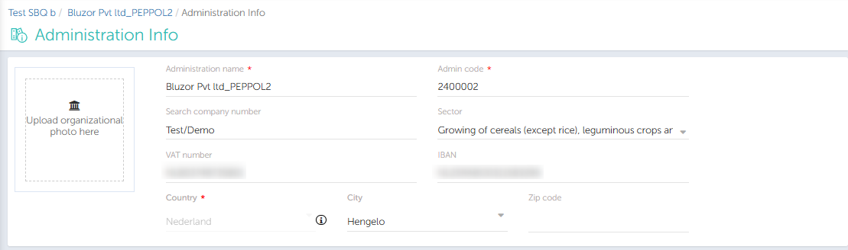

- On the VAT Coding page, make the appropriate VAT mapping. Template mapping should be checked if it is a follower admin.
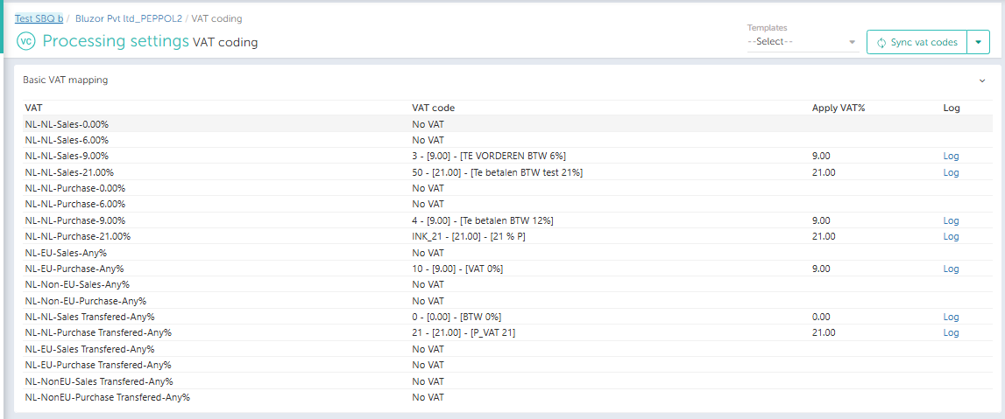

- Check the suspense code for the admin –
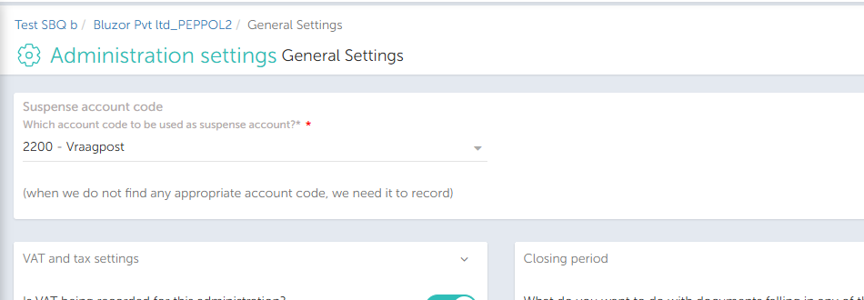

- Set/check the header and line Description settings.
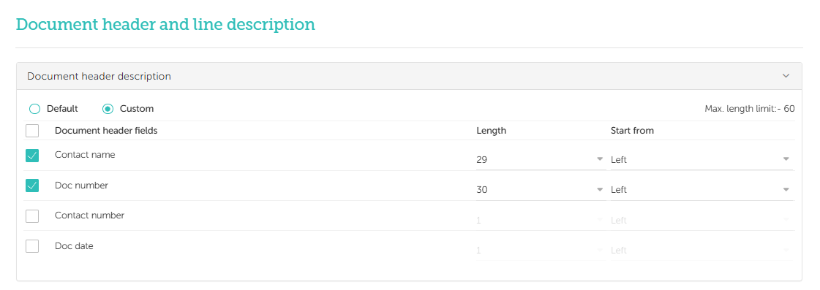

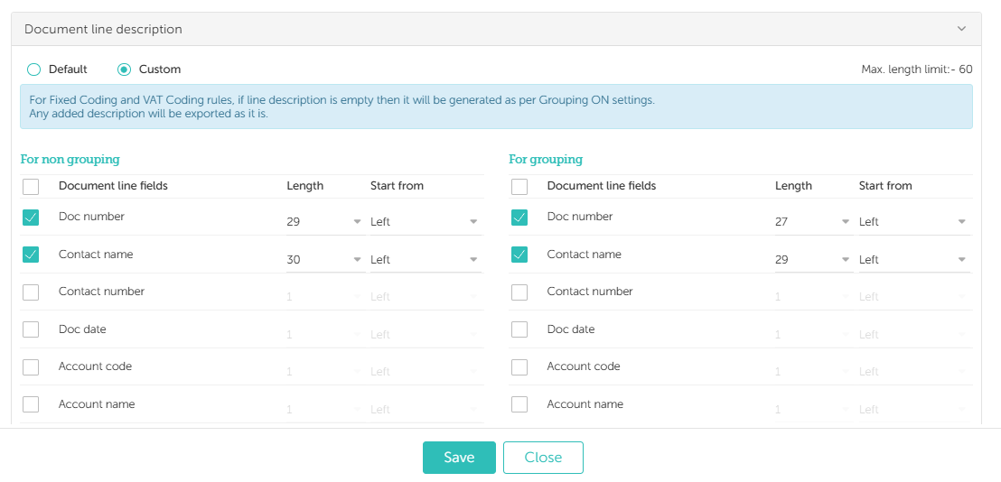

- Ensure Payment Terms (and other details) are set correctly for the admin.
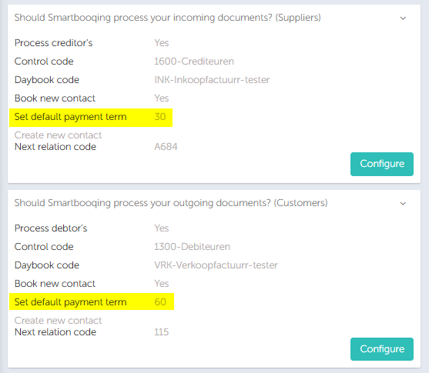

- Quickly glance over the relation list menu and its configurations –
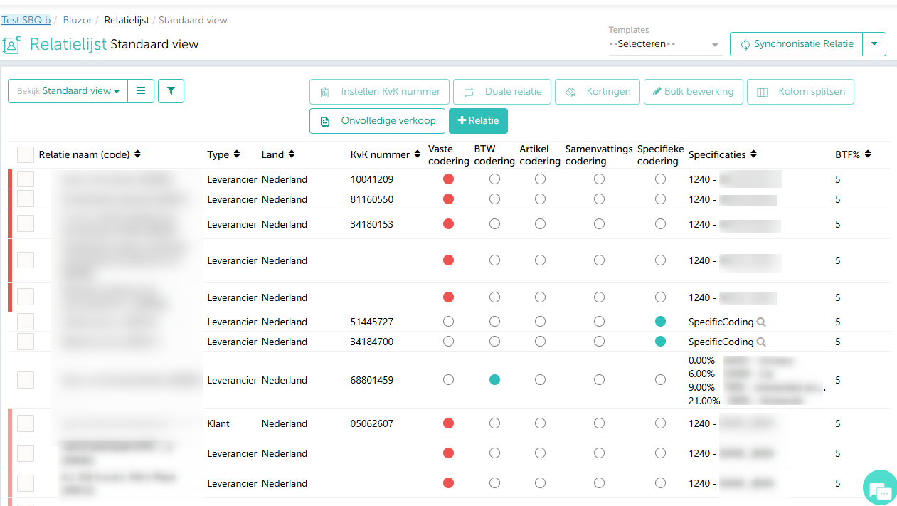

- Verify that the Synchronisation is functioning correctly for the admin.
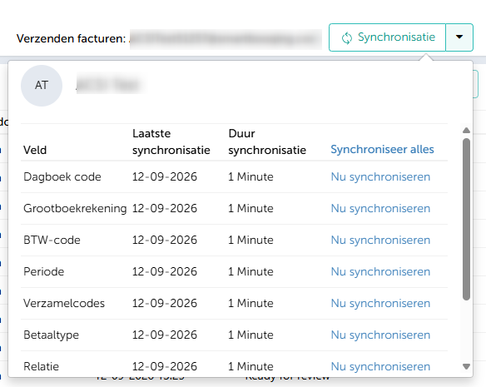

8. Go to the Contact List page, then set up the correct coding rule and account code for processing.
8. Go to the
9. Process documents and view invoices on the document detail page If the settings are incorrect: You can also configure the correct settings for the contact from the document detail page Or create a new contact.
