

Connecting to SmartUBL
Powered by Smartbooqing
‘A step-by-step instruction manual on connecting to the SmartUBL API’

Version 3.6.1
March 21, 2026
1 Introduction 2
1.1 Company Registration 3
1.2 API credentials 3
2 URL 3
3 Authentication 3
3.1. Request new bearer token 3
3.1.1. Request properties 3
3.2.1.1 Sample request 3
3.1.1.2. Sample Postman request 4
3.1.2. Response properties 4
3.1.2.1. Sample response 5
3.1.2.2. Possible error responses 5
3.2 Consume token in APIs 5
3.2.1 Sample API, how to set Token 6
3.2.2 Language 6
3.3 Refresh bearer token 6
3.3.1 Request properties 6
3.3.1.1 Sample request 7
3.3.1.2 Response properties 7
3.3.1.3 Sample response 7
3.3.1.4 Possible error responses 8
3.3.2 What if the refresh token expired? 8
3.3.3 Token validity periods 8
4 HTTP verbs 8
5 Status codes 8
6 APIs 9
6.1 Upload File 9
6.1.1 Request 9
6.1.1.1 Request properties 9
6.1.1.2 Sample request 9
6.1.1.3 Response properties 9
6.1.1.4 Sample response 9
6.1.1.5 Possible error responses 9
6.2 Get File status 10
6.2.1. Request 10
6.2.1.1. Request properties 10
6.2.1.1 Response properties 10
6.2.1.2 Sample response 10
6.2.1.3 Possible error responses 10
6.3 Download File 10
6.3.1 Request 10
6.3.1.1 Request properties 10
6.3.1.2 Response properties 11
6.3.1.3 Sample response 11
6.4 List documents 11
6.4.1 Request 12
6.4.1.1 Request properties 12
6.4.1.2 Response properties 12
6.4.1.3 Sample response 13
6.4.1.4 Possible error responses 13
6.5 Download UBL with DocumentID (without updating document status) 13
6.4.1. Request 14
6.5.1.1 Request properties 14
6.5.1.2 response properties 14
6.5.1.3 Sample response 14
6.5.1.4 Possible error responses 14
6.6 Download document PDF (with DocumentID as file name) 14
6.6.1 Request 14
6.6.1.1 Request properties 15
6.6.1.2 Sample request 15
6.6.1.3 Response properties 15
6.6.1.4 Sample response 15
6.6.1.5 Possible error responses 15
6.7 Mark documents as a read (Downloaded) 15
6.7.1 Request 16
6.7.1.1 Request properties 16
6.7.1.2 Sample request 16
6.7.1.3 Response properties 16
6.7.1.4 Sample response 16
6.7.1.5 Possible error responses 16
6.8 Get document status 16
6.8.1 Request 16
6.8.1.1 Request properties 17
6.8.1.2 Response properties 17
6.8.1.3 Sample response 17
6.9 List documents for specific file 18
6.9.1 Request 18
6.9.1.1 Request properties 18
6.9.1.2 Response properties 18
6.9.1.3 Sample response 18
6.10 Download UBL with FileID (update status as downloaded) 18
6.3.1. Request 18
6.10.1.1 Request properties 19
6.10.1.2 Response properties 19
6.10.1.3 Sample response 19
6.10.1.4 Possible error responses 19
6.11 Download UBL with DocumentID (update status as downloaded) 19
6.11.1 Request 20
6.11.1.1 Request properties 20
6.11.1.2 Response properties 20
6.11.1.3 Sample response 20
6.11.1.4 Possible error responses 21
6.12 Download document PDF (with name as system file name) 21
6.12.1 Request 21
6.12.1.1 Request properties 21
6.12.1.2 Response properties 21
6.12.1.3 Sample response 21
7 Webhooks 21
7.1 How to subscribe 22
7.2 Authentication 22
7.3 Retry cycle 22
7.4 Events 22
7.4.1 Document received 22
7.4.1.1 Payload properties 22
7.4.1.2 Sample payload 22
8 Appendix 23
8.1 UBL Warnings 23

Introduction
This document provides an overview of all possible communication with your data using SmartUBL APIs.

Company Registration
To use API’s, you need to have a user account on SmartUBL. If you do not have a user account on SmartUBL, then please contact us to create one.
You need to provide us the below details:
- Your name, email address, telephone number
- Company name, KVK number, Company address.
Note: If you are using SmartUBL via API and Portal. Then the login details are different for both.

API credentials
- Username
- Password
- Client id

Contact us at support@smartbooqing.com to get the above details.

URL
All requests are processed on api.smartubl.com domain. For future compatibility, SmartUBL maintains API versions. The current version is v1, which needs to be added in URL always. Therefore, the base URL for all APIs is as follows.
https://api.smartubl.com/api

Authentication
SmartUBL uses OAuth2 (Open Authentication 2) for all API interactions.

3.1. Request new bearer token
To request a token you need to post a request to sign-in
POST https://api.smartubl.com/api/v1/account/sign-in
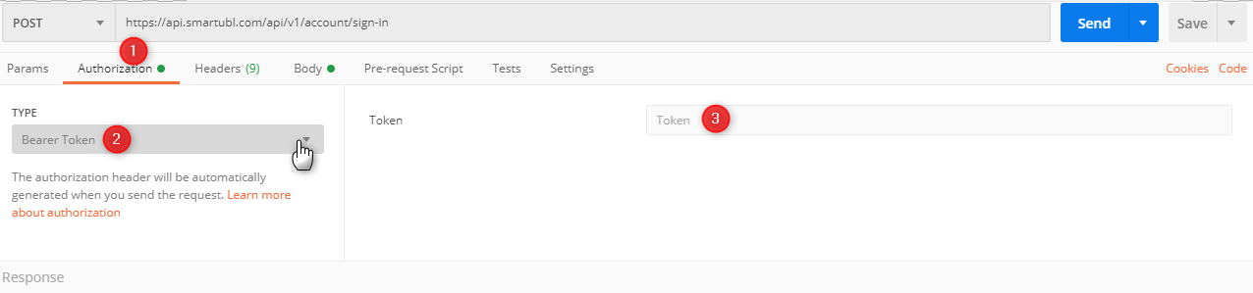

3.1.1. Request properties
Property | Type | Description
UserName | string | User’s user name
Password | string | User’s login password
ClientID | guid | User’s client ID

Sample request

{
"UserName”: “test@smarubl.com”,
"Password": “MyStrongPassword”,
"ClientID": “29C98625-B5AB-4449-86C0-1AE6BFC382D9”
}

3.1.1.2. Sample Postman request
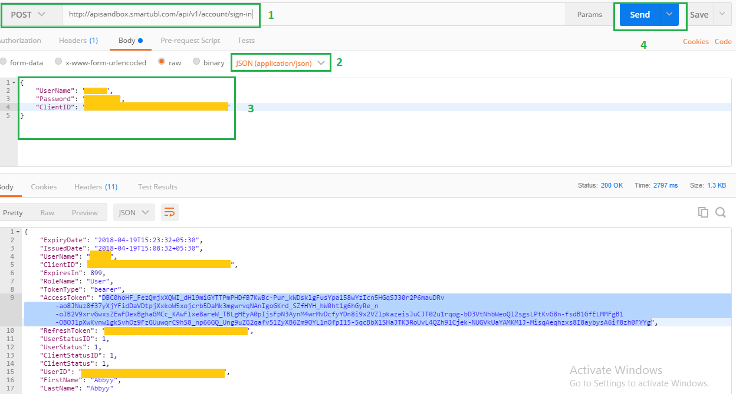

3.1.2. Response properties

Property | Type | Description
AccessToken | string | Access token
TokenType | string | Token type. Default “bearer”
ExpiresIn | int | Expires in seconds
RefreshToken | string | Refresh token to re-claim access token
RoleName | string | Role. Default “User”
ClientID | Guid | Client ID of user
UserName | string | User name
IssuedDate | date-time | Token issue date time
ExpiryDate | date-time | Token expiry date time
FirstName | string | First name of user
LastName | string | Last name of user
ClientStatus/ClientStatusID | int | For internal use
UserStatus/UserStatusID | int | For internal use
UserID | Guid | For internal use

3.1.2.1. Sample response

{
"ExpiryDate": "2018-04-19T11:18:27+02:00",
"IssuedDate": "2018-04-19T11:03:27+02:00",
"UserName": "*****",
"ClientID": " xxxxxxxx-xxxx-xxxx-xxxx-xxxxxxxxxxxx ",
"ExpiresIn": 899,
"RoleName": "User",
"TokenType": "bearer",
"AccessToken": "G06CEgox4lGRV_U9meoMIQX4TIh2kmUEWwuJbUR3jHk5MrwgqvKETXFkAUpK_ws--c9WnbLParMLBDAAq-VG1OYTeuJ7olQ4Orb0Jeo-o3vAw8TV32XJJdk1JZJbCIsYrhlScUEZUh4L7lye2sk1eSMZ8-Nd84qVAUpdzvqeAmR7Z04DO2gi3l92SAI1q4hh3sm-tVf2zDz2FPcgIB6gS8R6SqQpg6aUs3A7SfAgwKD9u9BBEbS98Ld6NU7dINVGHq0LksVQUV3DIYdzTDJEipLwF7QfUFGa336i3yDi9E3c8cPa_rIw9b0FbZoRoV0GDmK8plxua84RK-_2QL2btJgBF5_YwZTr3H_5cx8huiXLTZEDjZqHPZ3x3DWLaaosKA25QFJvPni580Mkv7Fy8BPojiDd54vb-Ue3giff4JXnHTQQ1f1CPTsFgel-m-9EPEBoZQIjMfPLt5JQ15tgow",
"RefreshToken": " xxxxxxxx-xxxx-xxxx-xxxx-xxxxxxxxxxxx ",
"UserStatusID": 1,
"UserStatus": 1,
"ClientStatusID": 1,
"ClientStatus": 1,
"UserID": “xxxxxxxx-xxxx-xxxx-xxxx-xxxxxxxxxxxx”
"FirstName": "abbyy",
"LastName": "abbyy"
}

3.1.2.2. Possible error responses

Error code | Error message | Remarks
400 | Invalid credentials | Credentials are incorrect
400 | Request is invalid | Malformed request

Consume token in APIs
You must pass the Access token received in the response above, to all API requests, which are authentication protected.
You would need this token for all the requests. Please copy it.
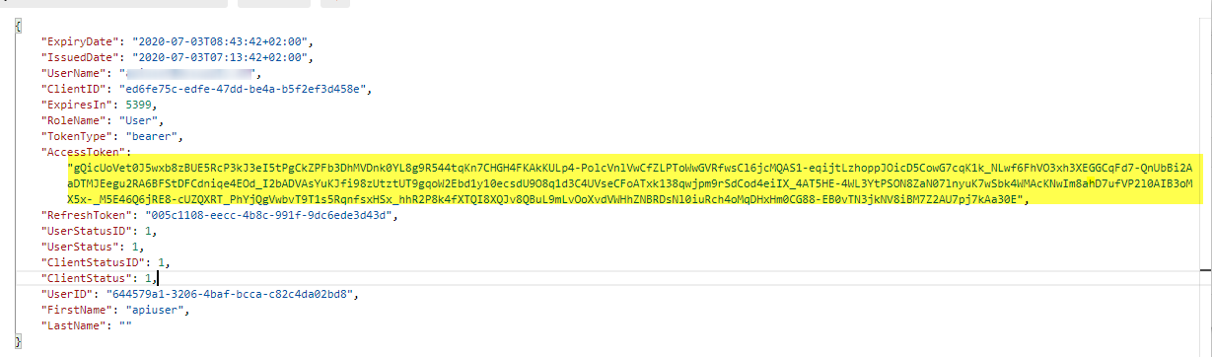

Sample API, how to set Token

GET https://api.smartubl.com/api/v1/documents/d1d24888-acec-4b77-8334-eacd0b753190/status
How to request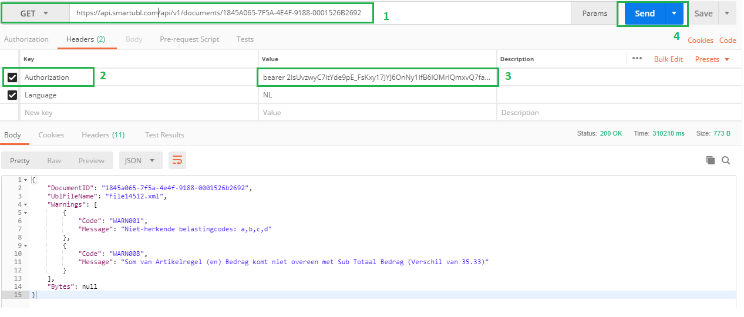

Language
To receive response in language other than English, send Language header with the language code as value. Currently only two languages are supported. Below are the languages that are supported along with their code –
- English (US) – en-US
- Dutch – nl-NL

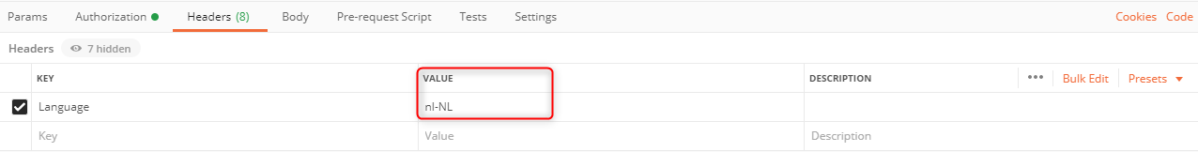

Refresh bearer token
To refresh the token, you need to post a request to refresh-token API from a valid API client.
POST https://api.smartubl.com/api/v1/account/refresh-token

Request properties

Property | Type | Description
RefreshToken | string | Refresh token returned during signin
ClientID | guid | User’s client ID

Sample request

{
"RefreshToken": “13c35164-79ef-49ab-8cb1-150960fb1a2”,
"ClientID": “29C98625-B5AB-4449-86C0-1AE6BFC382D9”
}

Response properties
Property | Type | Description
AccessToken | string | Access token
TokenType | string | Token type. Default “bearer”
ExpiresIn | int | Expires in seconds
RefreshToken | string | Refresh token to re-claim access token
RoleName | string | Role. Default “User”
ClientID | Guid | Client ID of user
UserName | string | User name
IssuedDate | date-time | Token issue date time
ExpiryDate | date-time | Token expiry date time
FirstName | string | First name of user
LastName | string | Last name of user
ClientStatus/ClientStatusID | int | For internal use
UserStatus/UserStatusID | int | For internal use
UserID | Guid | For internal use

Sample response

{
"ExpiryDate": "2018-04-19T11:18:27+02:00",
"IssuedDate": "2018-04-19T11:03:27+02:00",
"UserName": "*****",
"ClientID": " xxxxxxxx-xxxx-xxxx-xxxx-xxxxxxxxxxxx ",
"ExpiresIn": 899,
"RoleName": "User",
"TokenType": "bearer",
"AccessToken": "G06CEgox4lGRV_U9meoMIQX4TIh2kmUEWwuJbUR3jHk5MrwgqvKETXFkAUpK_ws--c9WnbLParMLBDAAq-VG1OYTeuJ7olQ4Orb0Jeo-o3vAw8TV32XJJdk1JZJbCIsYrhlScUEZUh4L7lye2sk1eSMZ8-Nd84qVAUpdzvqeAmR7Z04DO2gi3l92SAI1q4hh3sm-tVf2zDz2FPcgIB6gS8R6SqQpg6aUs3A7SfAgwKD9u9BBEbS98Ld6NU7dINVGHq0LksVQUV3DIYdzTDJEipLwF7QfUFGa336i3yDi9E3c8cPa_rIw9b0FbZoRoV0GDmK8plxua84RK-_2QL2btJgBF5_YwZTr3H_5cx8huiXLTZEDjZqHPZ3x3DWLaaosKA25QFJvPni580Mkv7Fy8BPojiDd54vb-Ue3giff4JXnHTQQ1f1CPTsFgel-m-9EPEBoZQIjMfPLt5JQ15tgow",
"RefreshToken": " xxxxxxxx-xxxx-xxxx-xxxx-xxxxxxxxxxxx ",
"UserStatusID": 1,
"UserStatus": 1,
"ClientStatusID": 1,
"ClientStatus": 1,
"UserID": “xxxxxxxx-xxxx-xxxx-xxxx-xxxxxxxxxxxx”
"FirstName": "abbyy",
"LastName": "abbyy"
}

Possible error responses
Error code | Error message | Remarks
400 | Invalid credentials | Credentials are incorrect
400 | Request is invalid | Malformed request

What if the refresh token expired?
As a universal practice, refresh tokens cannot be renewed. So, to get new refresh token you need to call Signin API, please refer section ‘3.1. Request new bearer token’.

Token validity periods

Token | Validity (minutes)
Refresh token | 90
Access token | 90
* Access token must be renewed before it expires. Suggested practice is to renew access token 5 minutes before its expiry.

HTTP verbs

Verb | Description
GET | Locates and returns list or single resource
PUT | Locates and updates resource
POST | Creates new resource
PATCH | Locates and updates resource partially
DELETE | Locates and deletes resource

Status codes

Code | Description
200 OK | Request successfully processed
500 Internal server error | Something went wrong with request.
401 Unauthorized | You are not authorized to access the resource
404 Resource not found | Resource you are looking for not found
400 bad request | Request parameter passed to request are invalid. Check spelling mistakes, data types, number of parameters, mandatory parameters
406 Unacceptable | Request is not acceptable
204 No content | There is no content available

APIs

Upload File
To upload a new document, supported file format is, PDF, JPG, JPEG, PNG,
Other file formats supported:
“.bmp", ".dib", ".rle" , ".djvu", ".djv" ,".gif",".jb2",".jbig2" , “jp2",".j2k",".jpf",".jpx",".jpc",".pcx",".dcx" ,".tif",".tiff" , ,".wdp",".wmp",".hdp” ,".xps",".ico",".icon"

Request
POST https://api.smartubl.com/api/v1/documents

Request properties

Property | Type | Description
DocumentName | string | Valid file name to identify file
TypeID | Int | “1” to process as vat line  “2” to process as invoice line
ClientNumber | string | Valid client number  Optional Value
Bytes | byte[] | Byte array of the document.  Note: Byte array in JSON is represented as base64 string.

Sample request

{
"DocumentName": "test1.pdf",
"TypeID": 2,
“ClientNumber”: “SE2021004474”
“Bytes”: <base64 string>
}

Response properties

Property | Type | Description
FileID | Guid | Returns a guid for the uploaded File

Sample response
"87611ad1-5b58-4f94-887b-defd3efa040e"

Possible error responses
Error code | Error message | Remarks
406 | Unsupported file format | File format is not supported
406 | Virus affected file | File is infected with virus
400 | Request is invalid | Malformed request

Get File status
To check the status of the document, if the file is processed, being processed, rejected.

6.2.1. Request
The file id that you received, you need that id. Insert the document id in the request in the highlighted section.
GET https://api.smartubl.com/api/v1/documents/87611ad1-5b58-4f94-887b-defd3efa040e/status

6.2.1.1. Request properties
Property | Type | Description
FileID | Guid | Guid of the file

Response properties
Property | Type | Description
DocumentID | Guid | Guid of document
StatusCode | int | “1” for process completed  “2” for in process  “3” for rejected
Status | string | Status message

Sample response
{
"DocumentID": "d1d24888-acec-4b77-8334-eacd0b753190",
"StatusCode": 1,
"Status": "Process completed"
}

Possible error responses
Error code | Error message | Remarks
404 | Document not found | DocumentID is incorrect
400 | Request is invalid | Malformed request

Download File
To get the original file that was submitted.

Request
The file id that you received, you need that id. Insert the document id in the request in the highlighted section.

GET https://api.smartubl.com/api/v1/documents/87611ad1-5b58-4f94-887b-defd3efa040e/download/file

Request properties

Property | Type | Description
FileID | Guid | Guid of the document

Response properties

Property | Type | Description
FileDownloadName | string | File name for the file
ContentType | string | Mime type of file.
FileContents | byte[] | Array of bytes of Ubl file data  Note: Byte array in JSON is represented as base64 string.
SourceFileSize | double | Original File size(Kb)

Sample response

{
"FileDownloadName": "test.pdf",
"ContentType": "application/pdf",
"FileContents": “base64 string of ubl file”,
"SourceFileSize": 51.0,
}

List documents

To get list of processed documents.

Request
GET https://api.smartubl.com/api/v2/documents?PageIndex=1&PageSize=100&hasRead=true&StartDate=2024-04-25&EndDate=2024-09-15&Orderby=SubmittedOn&OrderDirection=desc

Request properties
Property | Type | Is Required | Description
PageIndex | int | Yes | Represent which group of files you want
PageSize | int | Yes | How many records in a page
hasRead | bool | No | Represent if the file already downloaded or not
Orderby | string | No | Ordering Column. This not passed then default ordering on file ReceivedOn
OrderDirection | string | No | Ordering direction “asc, desc”
StartDate | date-time | No | File submission starting date in the format of “yyyy-MM-dd”
EndDate | date-time | No | File submission ending date in the format of “yyyy-MM-dd”

Response properties
Property | Type | Description
CurrentPageIndex | int | Represent current page out of how many pages
TotalRecordCount | int | Total Items count
PageSize | int | The count of items per page
TotalNumberOfPages | int | Total Pages
List | Object [] | Represent the documents you have
items. DocumentID | Guid | Document id
items. DocumentProcessedOn | Date-time | Date when the document be created
items. FileID | Guid | File id
Items.ClientNumber | string | ClientNumber which submitted with file
items. FileName | string | The uploading name of the file
items. FileStatus | int | Status of the file
items.SubmittedBy | string | The name of the user who uploaded the invoice
items.SubmittedOn | Date-time | Date when we received the invoice
items.hasRead | bool | Represent if the document downloaded or not
items.InvoicesCount | int | 1
items.SourceFileSize | double | Original File size in (Kb)
items.DocumentPdfSize | double | Invoice file size in (Kb)

Sample response
- {
- "List": [
- {
- "FileID": "b95f3674-2b76-4f57-9894-9a83bfcd660d",
- "FileName": "Buyer reference.pdf",
- "DocumentID": "f0347b30-9a3b-4402-94ab-30e310e1fcc9",
- "DocumentProcessedOn": "2024-09-12T10:48:39.66",
- "FileStatus": 5,
- "ClinetNumber": "SE2321000073",
"SubmittedBy": "submitter@bluzor.com",
- "SubmittedOn": "2024-09-12T10:36:33.8733333",
- "HasRead": false,
- "InvoicesCount": 1,
- "SourceFileSize": 101.0,
- "DocumentPdfSize": 43.0
- },
- {
- "FileID": "9f1f4bdf-86f6-4bd5-a522-f51b3801c86f",
- "FileName": "Buyer reference.pdf",
- "DocumentID": "82fbe2ba-db47-400e-b578-392362adc6f9",
- "DocumentProcessedOn": "2024-09-11T12:50:40.693",
- "FileStatus": 5,
- "ClinetNumber": "SE23125648073",
"SubmittedBy": "submitter@bluzor.com",
- "SubmittedOn": "2024-09-11T10:49:39.0633333",
- "HasRead": false,
- "InvoicesCount": 1,
- "SourceFileSize": 101.0,
- "DocumentPdfSize": 43.0
- }
- ],
- "TotalRecordCount": 44,
- "CurrentPageIndex": 1,
- "PageSize": 2,
- "TotalNumberOfPages": 22
- }

Possible error responses
Error code | Error message | Remarks
500 | Authentication Failed | Update Your Token
400 | Request is invalid | Malformed request

Download UBL with DocumentID (without updating document status)
This endpoint is just alternate for download UBL endpoint. Here we return 404 error response code instead of 204 if document is rejected or in progress.
Note: The ideal time to get back the processed UBL is 24 hours.
Note: This API return UBL without updating document status as ‘downloaded’.
To update status as downloaded, call API 6.12 Mark file as a read (Downloaded).

6.4.1. Request
The file id that you received, you need that id. Insert the document id in the request in the highlighted section.

GET https://api.smartubl.com/api/v1/documents/8466efa1-75af-4e19-bd07-e8f673c7cea6/download/ubl

Request properties

Property | Type | Description
DocumentID | Guid | Guid of the document

response properties

Property | Type | Description
FileDownloadName | string | File name for the Ubl
Warnings | Array of warnings with properties – Code (string) and Message (string) | Warnings with code and message
Bytes | byte[] | Array of bytes of Ubl file data  Note: Byte array in JSON is represented as base64 string.
SourceFileSize | double | Original File size in (Kb)
DocumentPdfSize | double | Invoice file size in (Kb)

Sample response

{
"FileContents": "base64",
"ContentType": "application/octet-stream",
"FileDownloadName": "API_SL submitted by.xml",
"SourceFileSize": 101.0,
"DocumentPdfSize": 43.0
}

Possible error responses
Error code | Error message | Remarks
404 | Document not found | DocumentID is incorrect
404 | No content | File is rejected or is in process
400 | Request is invalid | Malformed request

Download document PDF (with DocumentID as file name)
To Update document status to be downloaded.

Request
GET https://api.smartubl.com/api/v3/documents/80d775a2-d098-4440-94c8-fe8edcc020be/pdf

Request properties
Property | Type | Description
DocumentID | Guid | Guid of the document

Sample request
GET https://api.smartubl.com/api/v3/documents/80d775a2-d098-4440-94c8-fe8edcc020be/pdf

Response properties
Property | Type | Description
FileDownloadName | string | {DocumentID}.pdf
ContentType | string | Mime type of file.  https://slick.pl/kb/htaccess/complete-list-mime-types/
FileContents | byte[] | Array of bytes of PDF file data  Note: Byte array in JSON is represented as base64 string.
DocumentPdfSize | double | Invoice file size in (Kb)

Sample response

{
"FileDownloadName": "80d775a2-d098-4440-94c8-fe8edcc020be.pdf",
"ContentType": "application/pdf",
"FileContents": “base64 string of PDF file”,
"DocumentPdfSize": 43.0
}

Possible error responses
Error code | Error message | Remarks
401 | Authentication Failed | Update Your Token
400 | Request is invalid | Malformed request

Mark documents as a read (Downloaded)
- To Update document status to be downloaded.

Request
- POST https://api.smartubl.com/api/v2/documents/read

Request properties
Property | Type | Description
DocumentIDs | List Guid | List of the DocumentID which need to be updated

Sample request
- [
- "e8d88acd-2df5-41ce-aad2-f9b8496c1c2c",
"cd8fcc9f-0bef-4506-84d4-5f24c51710bf"
- ]

Response properties
Property | Type | Description
List | Object [] | Represent the document and the status
DocumentStatus. ID | GUID | DocumentID
DocumentStatus. hasRead | bool | Document read status

Sample response
- [
- {
- "ID": "e8d88acd-2df5-41ce-aad2-f9b8496c1c2c",
- "HasRead": true
- },
- {
- "ID": "cd8fcc9f-0bef-4506-84d4-5f24c51710bf",
- "HasRead": true
- }
- ]

Possible error responses
Error code | Error message | Remarks
500 | Authentication Failed | Update Your Token
400 | Request is invalid | Malformed request
204 | Partial success | Some files updated and some not updated

Get document status
To get the list of documents from file

Request
The document id that you received against file id, you need that id. Insert the document ID in the request in the highlighted section.

GET https://api.smartubl.com/api/v2/documents/80d775a2-d098-4440-94c8-fe8edcc020be/status

Request properties

Property | Type | Description
DocumentID | Guid | ID of the document

Response properties

Property | Type | Description
DocumentId | Guid | Document ID
Status | String | Document status
StatusCode | Int | Document status code

Sample response

{
" DocumentId ": " Document Id ",
" Status ": " Document status ",
" StatusCode ": “Document status code”
}

List documents for specific file
To get the list of documents from file, if file has multiple invoices.

Request
The file id that you received, you need that id. Insert the fil id in the request in the highlighted section.

GET https://api.smartubl.com/api/v2/files/6ec5933f-67bf-43ee-892a-a4e85757dd9d/documents

Request properties

Property | Type | Description
FileID | Guid | ID of the submitted file

Response properties

Property | Type | Description
DocumentId | Guid | Document ID from file
FileStatus | String | Document status
FileSubStatus | String | Document sub status
FileStatusCode | Int | Document status code
FileSubStatusCode | Int | Document sub status code
ClientNumber | string | ClientNumber which submitted with file

Sample response

{
" DocumentId ": " Document Id ",
" FileStatus ": " Document status ",
"ClientNumber": "SE23125648073",
" FileSubStatus ": “Document sub status”,
" FileStatusCode ": “Document status code”,
" FileStatusCode ": “Document sub status code”
}

Download UBL with FileID (update status as downloaded)
To get the processed/converted UBL.
Note: The ideal time to get back the processed UBL is 24 hours.
Note: This API return UBL and update document status as ‘downloaded’.

6.3.1. Request
The file id that you received, you need that id. Insert the document id in the request in the highlighted section.
GET https://api.smartubl.com/api/v1/documents/87611ad1-5b58-4f94-887b-defd3efa040e

Request properties
Property | Type | Description
FileID | Guid | Guid of the file

Response properties
Property | Type | Description
DocumentID | Guid | Guid of the document
UblFileName | string | File name for the Ubl
Warnings | Array of warnings with properties – Code (string) and Message (string) | Warnings with code and message.
Bytes | byte[] | Array of bytes of UbL file data  Note: Byte array in JSON is represented as base64 string.
SourceFileSize | double | Original File size in (Kb)
DocumentPdfSize | double | Invoice file size in (Kb)

Sample response
{
"DocumentID": "d1d24888-acec-4b77-8334-eacd0b753190",
"UblFileName": "test1.xml",
“Warnings”: [
{
“Code”: “WARN005”,
“Message”: “Credit and debit amount mismatch by 0.53”
},
{
“Code”: “WARN004”,
“Message”: “Vendor name is trimmed to first 50 characters”
}
],
"Bytes": “base64 string of ubl file”,
"SourceFileSize": 101.0,
"DocumentPdfSize": 43.0
}

Possible error responses
Error code | Error message | Remarks
404 | Document not found | DocumentID is incorrect
204 | No content | File is rejected or is in process
400 | Request is invalid | Malformed request

Download UBL with DocumentID (update status as downloaded)
This endpoint is used download ubl against document ID
Note: This API return UBL and update document status as ‘downloaded’.

Request
The document id that you received against file, you need that id. Insert the document id in the request in the highlighted section.

GET https://api.smartubl.com/api/v2/documents/80d775a2-d098-4440-94c8-fe8edcc020be

Request properties

Property | Type | Description
DocumentID | Guid | Guid of the document

Response properties

Property | Type | Description
DocumentID | Guid | Guid of the document
UblFileName | string | File name for the Ubl
Warnings | Array of warnings with properties – Code (string) and Message (string) | Warnings with code and message
Bytes | byte[] | Array of bytes of Ubl file data  Note: Byte array in JSON is represented as base64 string.
SourceFileSize | double | Original File size in (Kb)
DocumentPdfSize | double | Invoice file size in (Kb)
ClientNumber | string | ClientNumber which submitted with file

Sample response

{
"DocumentID": "d1d24888-acec-4b77-8334-eacd0b753190",
"UblFileName": "test1.xml",
“Warnings”: [
{
“Code”: “WARN005”,
“Message”: “Credit and debit amount mismatch by 0.53”
},
{
“Code”: “WARN004”,
“Message”: “Vendor name is trimmed to first 50 characters”
}
],
"Bytes": “base64 string of ubl file”,
"SourceFileSize": 101.0,
"ClientNumber": "SE23125648073",
"DocumentPdfSize": 43.0
}

Possible error responses

Error code | Error message | Remarks
404 | Document not found | DocumentID is incorrect
404 | No content | File is rejected or is in process
400 | Request is invalid | Malformed request

Download document PDF (with name as system file name)
To get the pdf file against document.

Request
The document id that you received against file, you need that id. Insert the document id in the request in the highlighted section.

GET https://api.smartubl.com/api/v2/documents/80d775a2-d098-4440-94c8-fe8edcc020be/pdf

Request properties

Property | Type | Description
DocumentID | Guid | Guid of the document

Response properties

Property | Type | Description
FileDownloadName | string | system file name
ContentType | string | application/octet-stream
FileContents | string | base64 string.
DocumentPdfSize | double | Invoice file size in (Kb)

Sample response

{
"FileDownloadName": " Batch HF_ID-7278135b8eba62-036e-4214-b7e2-7b2b4273f571_240718092359_Client=Go2Ubl_Case=NA_NA_ID=9a1adc2c-7b4b-4470-b33e-5cf8329484e9_-523794.pd f",
"ContentType": " application/octet-stream ",
"FileContents": “base64 string of document pdf file”,
"DocumentPdfSize": 43.0
}

Webhooks
Webhooks help subscribers to receive instant information on the events happening in SmartUBL.

How to subscribe
Currently, we do not support subscription using UI. To subscribe webhooks please, create a support ticket with subject “Webhook subscription requested” and provide following information:
ClientID | {GUID}  (Provided to you while registration)
Credentials | {Crednetials}  (As we support basic authentication, subscriber needs to provide username & password or a base64(username + ’:” + password)
Subscription Url | {WebUrl}  (Url on which you want to receive event payloads)

On receiving request, we will register a webhook and you will start receiving requests.

Authentication
We support basic authentication for webhook subscriptions. So, in every event request you will receive authentication header as following:
Authorization | Base64(UserName + “:” + Password)
More information on Basic Authentication can be found on: https://en.wikipedia.org/wiki/Basic_access_authentication

Retry cycle
For every request we expect your Url to return a HTTP response code 200 OK. On receiving 200 OK response we consider that you have processed request successfully. If Url returns any response code other than 200 OK, we will keep retrying the same request with following internals.
1st retry | 1 hour from event time
2nd retry | 8 hours from event time
3rd retry | 16 hours from event time
4th retry | 24 hours from event time
5th retry | 40 hours from event time

Events
We support following events for webhooks

Document received
This event is triggered when we will receive a document for processing.

Payload properties
Property | Type | Description
DocumentID | Guid | Valid file name to identify file
TypeID | Int | “1” to process as vat line  “2” to process as invoice line

Sample payload
{
"DocumentID": "87611ad1-5b58-4f94-887b-defd3efa040e",
"TypeID": 2
}

Note: Each event request has authentication header (described in 8.2 Authentication section) so it is strongly recommended to authenticate request while consumption.

Appendix

UBL Warnings
Document provides an overview of all possible warnings along with their explanation and how it affects the generated UBL.
All the warnings are returned through API upon request to download UBL. The response contains UBL file along with the list of warnings. A unique code assigned to each warning.
Note – The {0} in warning message is a variable and will be replaced by appropriate text in actual warning message.

- Unrecognized Tax Codes: {0} [WARN001]

Reason/Criteria/Calculations/Explanation –
When a tax code (VAT code) is not recognized by our system, this warning will be shown.
Below is the list of tax codes recognized by our system:
- For 0%
      - 0 (0%, 0.00, 0.00%)
      - EM
- For 6%
  - 6 (6%, 6.00, 6.00%)
  - L
  - Laag
- For 21%
      - 21 (21%, 21.00, 21.00%)
      - H
      - Hoog
The warning will also list all the tax codes, which were not recognized by the system in the message.
About UBL –
All the lines that have unrecognized tax code will be considered as 0 VAT lines in the UBL. Therefore, the UBL generated will have 0% tax applied on the lines that have unrecognized tax code.

- Article Line(s) are not captured [WARN002]

Reason/Criteria/Calculations/Explanation –
Below are some reasons because of which articles line(s) could not be captured:
- Non-NL invoice.
- Invoice articles line(s) are not readable.
- User explicitly asked to process as vat line (UBL Compact) i.e. without invoice articles line(s).
About UBL –
UBL will be created with only one line with article line description as combination of Vendor name, invoice date and invoice number (VendorName-InvoiceDate-InvoiceNumber), article line amount as total tax exclusive amount and 0% as VAT.

- Invoice Number is trimmed to last {0} characters [WARN003]

Reason/Criteria/Calculations/Explanation –
The average maximum invoice number length is 25 characters. Hence, the invoice number is trimmed to last 25 characters.
About UBL –
UBL will contain a trimmed invoice number of last 25 characters.

- Vendor Name is trimmed to first {0} characters [WARN004]

Reason/Criteria/Calculations/Explanation –
The average maximum vendor name length is 50 characters. Hence, the vendor name is trimmed to first 50 characters.
About UBL –
UBL will contain a trimmed vendor name of first 50 characters.

- Credit and Debit Amounts mismatch by {0} [WARN005]

This warning is now deprecated and no longer used.

- Non-Euro currency! It must be present in your accounting system to import this UBL [WARN006]

Reason/Criteria/Calculations/Explanation –
Warning is shown when an invoice has any currency code other any EUR.
About UBL –
UBL is created with that Non-Euro currency.

- Sub Total Amount + Tax Amount do not match with the Invoice Total Amount (Difference of {0}) [WARN007]

Reason/Criteria/Calculations/Explanation –
When sum of tax exclusive amount and tax amount do not match with the invoice total amount, this warning is shown. In addition, the difference between those amounts will be shown.
About UBL –
UBL will be created with those amounts anyway.

- Sum of Article Line(s) Amount do not match with Sub Total Amount (Difference of {0}) [WARN008]

Reason/Criteria/Calculations/Explanation –
When sum of the entire article line amount total tax exclusive amount, this warning is shown. In addition, the difference between those amounts will be shown.

About UBL –
UBL will be created with those amounts anyway.

- Quantity not present for {0} Article Line(s) [WARN009]

Reason/Criteria/Calculations/Explanation –
When quantity is not present for one or more article line(s), this warning is shown along with the number of line(s).
About UBL –
UBL will be created without quantity for those lines

- Unit Price not present for {0} Article Line(s) [WARN010]

Reason/Criteria/Calculations/Explanation –
When unit price is not present for one or more article line(s), this warning is shown along with the number of line(s).

About UBL –
UBL will be created without unit price for those lines.

- Unit Price and Quantity not present for {0} Article Line(s) [WARN011]

Reason/Criteria/Calculations/Explanation –
When unit price as well as quantity are not present for one or more article line(s), this warning is shown along with the number of line(s).

About UBL –
UBL will be created without unit price and quantity for those lines.

- Unit Price and Quantity do not match with Article Line(s) Amount for {0} Article Line(s) [WARN012]

Reason/Criteria/Calculations/Explanation –
When multiplication unit price with quantity do not match with line amount for one or more article line(s), this warning is shown along with the number of line(s).

About UBL –
UBL will be created with such unit price and quantity anyway.

- 6% Tax Amount do not match with 6% Calculated Tax of Article Line(s) Amount (Difference of {0}) [WARN013]

Reason/Criteria/Calculations/Explanation –
Sum of tax of all 6% vat lines is matched with the given 6% tax amount. If they do not match, this warning is shown along with difference in amount. This warning will not be shown if there are any unrecognized VAT codes on invoice or there are no VAT on all the lines at all.

About UBL –
UBL will be created with those lines anyway.

- 9% Tax Amount do not match with 9% Calculated Tax of Article Line(s) Amount (Difference of {0}) [WARN028]

Reason/Criteria/Calculations/Explanation –
Sum of tax of all 9% vat lines is matched with the given 9% tax amount. If they do not match, this warning is shown along with difference in amount. This warning will not be shown if there are any unrecognized VAT codes on invoice or there are no VAT on all the lines at all.

About UBL –
UBL will be created with those lines anyway.

- 21% Tax Amount do not match with 21% Calculated Tax of Article Line(s) Amount (Difference of {0}) [WARN014]

Reason/Criteria/Calculations/Explanation –
Sum of tax of all 21% vat lines is matched with the given 21% tax amount. If they do not match, this warning is shown along with difference in amount. This warning will not be shown if there are any unrecognized VAT codes on invoice or there are no VAT on all the lines at all.

About UBL –
UBL will be created with those lines anyway.
- 0% Tax Amount do not match with 0% Calculated Tax of Article Line(s) Amount (Difference of {0}) [WARN015]

Reason/Criteria/Calculations/Explanation –
Sum of tax of all 0% vat lines is matched with the given 0% tax amount. If they do not match, this warning is shown along with difference in amount. This warning will not be shown if there are any unrecognized VAT codes on invoice or there are no VAT on all the lines at all.

About UBL –
UBL will be created with those lines anyway.

- Total Tax Amount do not match with Sum of Tax Bifurcation(s) (Difference of {0}) [WARN016]

Reason/Criteria/Calculations/Explanation –
Total tax amount is broken down percentwise – 0, 6, 21, other. When sum of all these broken down amounts do not match with total tax amount, this warning is shown along with the difference.

About UBL –
UBL will be created with those amounts anyway.

- 6% Sub Total Amount do not match with Sum of 6% Article Line(s) Amount (Difference of {0}) (Difference of {0}) [WARN029]

Reason/Criteria/Calculations/Explanation –
Sum of all 6% vat lines amount is matched with the given 6% tax exclusive amount. If they do not match, this warning is shown along with difference in amount. This warning will not be shown if there are any unrecognized VAT codes on invoice or are no VAT on all the lines at all.

About UBL –
UBL will be created with those lines anyway.

- 9% Sub Total Amount do not match with Sum of 9% Article Line(s) Amount (Difference of {0}) (Difference of {0}) [WARN028]

Reason/Criteria/Calculations/Explanation –
Sum of all 9% vat lines amount is matched with the given 9% tax exclusive amount. If they do not match, this warning is shown along with difference in amount. This warning will not be shown if there are any unrecognized VAT codes on invoice or there are no VAT on all the lines at all.

About UBL –
UBL will be created with those lines anyway.

- 21% Sub Total Amount do not match with Sum of 21% Article Line(s) Amount (Difference of {0}) (Difference of {0}) [WARN018]

Reason/Criteria/Calculations/Explanation –
Sum of all 21% vat lines amount is matched with the given 21% tax exclusive amount. If they do not match, this warning is shown along with difference in amount. This warning will not be shown if there are any unrecognized VAT codes on invoice or there are no VAT on all the lines at all.

About UBL –
UBL will be created with those lines anyway.

- 0% Sub Total Amount do not match with Sum of 0% Article Line(s) Amount (Difference of {0}) (Difference of {0}) [WARN019]

Reason/Criteria/Calculations/Explanation –
Sum of all 0% vat lines amount is matched with the given 0% tax exclusive amount. If they do not match, this warning is shown along with difference in amount. This warning will not be shown if there are any unrecognized VAT codes on invoice or there are no VAT on all the lines at all.

About UBL –
UBL will be created with those lines anyway.

- Total Sub Total Amount do not match with Sum of Sub Total Bifurcation(s) (Difference of {0}) [WARN020]

Reason/Criteria/Calculations/Explanation –
Total tax exclusive amount is broken down percentwise – 0, 6, 21, other. When sum of all these broken down amounts do not match with total tax exclusive amount, this warning is shown along with the difference.

About UBL –
UBL will be created with those amounts anyway.

- 6% Sub Total Amount do not match with 6% Tax Amount (Difference of {0}) [WARN021]

Reason/Criteria/Calculations/Explanation –
6% tax amount should be equal to 6% of 6% tax exclusive amount. If not, this warning is shown along with the difference.

About UBL –
UBL will be created with those amounts anyway.

- 9% Sub Total Amount do not match with 9% Tax Amount (Difference of {0}) [WARN027]

Reason/Criteria/Calculations/Explanation –
6% tax amount should be equal to 9% of 9% tax exclusive amount. If not, this warning is shown along with the difference.

About UBL –
UBL will be created with those amounts anyway.

- 21% Sub Total Amount do not match with 21% Tax Amount (Difference of {0}) [WARN022]

Reason/Criteria/Calculations/Explanation –
21% tax amount should be equal to 21% of 21% tax exclusive amount. If not, this warning is shown along with the difference.

About UBL –
UBL will be created with those amounts anyway.

- 0% Sub Total Amount do not match with 0% Tax Amount (Difference of {0}) [WARN023]

Reason/Criteria/Calculations/Explanation –
0% tax amount should be equal to 0% of 0% tax exclusive amount. If not, this warning is shown along with the difference.

About UBL –
UBL will be created with those amounts anyway.

- No VAT Line(s) present [WARN024]

Reason/Criteria/Calculations/Explanation –
Warning is shown when invoice has no VAT on any of the lines.

About UBL –
UBL will be created with 0% VAT on all the lines.

