**Scope document for SmartPeppol**



**Version : 1.0**

**Date : 13 April, 2023**

**Submitted to :**

Table of Contents

1. SmartPeppol – a distinctive step towards a digital ecosystem 3

2. Schematic web – Connection with SmartPeppol 4

3. Supported document formats: 5

4. Client Options 8

5. Countries Supported 8

6. SmartPeppol Self Registration Flow: 10

7. Detailed steps to register/ Onboard with SmartPeppol 11

# SmartPeppol – a distinctive step towards a digital ecosystem

Our Smart PEPPOL module enables trading partners to exchange standards-based electronic documents (UBLs) between sending (suppliers) and receiving (buyers) parties.

Smart PEPPOL enables our clients to connect with all possible PEPPOL partners in one single system, making business transactions significantly easier. It helps to accelerate public and private sector digitization and harmonize standards.

# Schematic web – Connection with SmartPeppol

Following diagram represents exchange of E-Invoices powered by SmartPeppol portal:

# Supported document formats:

Following formats are supported by Smartpeppol to Send or Receive via Peppol:

Note: Any document type can be toggled ON or OFF from settings as per client requirement

* AU-NZ Peppol BIS Billing 3.0 CreditNote
* AU-NZ Peppol BIS Billing 3.0 Invoice
* AU-NZ Self-Billing 3.0 CreditNote
* AU-NZ Self-Billing 3.0 Invoice
* DespatchAdvice_IT
* DHSC Customized Ordering profile Order V1
* EHF Advanced Order Cancellation 3.0
* EHF Advanced Order Change 3.0
* EHF Advanced Order Initiation 3.0
* EHF Advanced Order Response 3.0
* EN 16931 CII Invoice
* EN 16931 UBL CreditNote
* EN 16931 UBL Invoice
* OIOUBL Reminder V2.02
* OIOUBL UtilityStatement V2.02
* OrderResponse_IT
* PEF.PL Accounting Note v1
* PEF.PL Correcting Invoice v1
* PEF.PL Receipt Advice v1
* Peppol BIS Billing CII Invoice V3
* Peppol BIS Billing UBL CreditNote V3
* Peppol BIS Billing UBL Invoice V3
* Peppol Catalogue Response transaction 3.0
* Peppol Catalogue transaction 3.0
* Peppol Despatch Advice transaction 3.0
* Peppol Invoice Response transaction 3.0
* Peppol Message Level Response transaction 3.0
* Peppol Order Agreement transaction 3.0
* Peppol Order Response transaction 3.0
* Peppol Order transaction 3.0
* Peppol Punch Out transaction 3.0
* SG Peppol BIS Billing 3.0 Credit Note
* SG Peppol BIS Billing 3.0 Invoice
* SimpleOrder_IT
* SI-UBL 1.2 Invoice
* SI-UBL 1.2 Order
* SI-UBL 2.0 CreditNote
* SI-UBL 2.0 G-Account Extension
* SI-UBL 2.0 Invoice
* Standalone Credit Note according to EHF V1
* UBL.BE Credit Note 3.0
* UBL.BE Invoice 3.0
* XRechnung CII Invoice V2.0
* XRechnung CII Invoice V2.0 Extension
* XRechnung UBL CreditNote V2.0
* XRechnung UBL CreditNote V2.0 Extension
* XRechnung UBL Invoice V2.0
* XRechnung UBL Invoice V2.0 Extension

*Please find a screenshot from SmartPeppol portal below:*

# Client Options

Following functionalities are available and can be opted by the client as per requirement:

1. **Peppol IN ONLY**

Here E-Invoices (UBLs) will be received via Peppol to client End Point but Outgoing Invoices will be disabled. This can be used as a ‘receiving only’.

1. **Peppol IN + OUT**

Here E-Invoices (UBLs) will be received and can also be sent to any contact’s End Point via Peppol. This is the full functionality of Peppol digital ecosystem.

1. **Peppol first, email second**

Further to B), here, E-Invoices (UBLs) will be shared via Peppol to contacts (1st prio), if the contact is not present on Peppol, the E-Invoice (UBL) will be delivered via E-mail. This completes the link for all clients and acts as a one stop solution

1. **Onboarding campaign for contacts**

Further to C), those contacts which are not present on Peppol can be onboarded via SmartPeppol and can start using Peppol functionality.

# Countries Supported

Following is the list of all countries supported for SmartPeppol portal:

* Albania
* Andorra
* Australia
* Belgium
* Bosnia and Herzegovina
* Bulgaria
* Cyprus
* Denmark
* Germany
* Espagne
* Estonia
* Finland
* France
* Greece
* Grand Duchy of Luxembourg
* Hungary
* Ireland
* Iceland
* Italy
* Japan
* Croatia
* Latvia
* Liechtenstein
* Lithuania
* Macedonia
* Malta
* Monaco
* The Netherlands
* Norway
* Austria
* Poland
* Portugal
* Republic of Singapore
* Romania
* San Marino
* Slovenia
* Slovakia
* Czech Republic
* Turkey
* Vatican CITY
* United Kingdom
* United States
* Sweden
* Switzerland

# SmartPeppol Self Registration Flow:

Clients can subscribe to our PEPPOL services using the following link,

<https://app.smartpeppol.com/nl-NL/signin>

This link will help you register yourself to Smartbooqing PEPPOL services and create a user profile for your company. The following page would be displayed, where you can simply click on “Register now” to move forward.

# Detailed steps to register/ Onboard with SmartPeppol

Following steps can guide you to register with SmartPeppol using the link shared in Step 6:

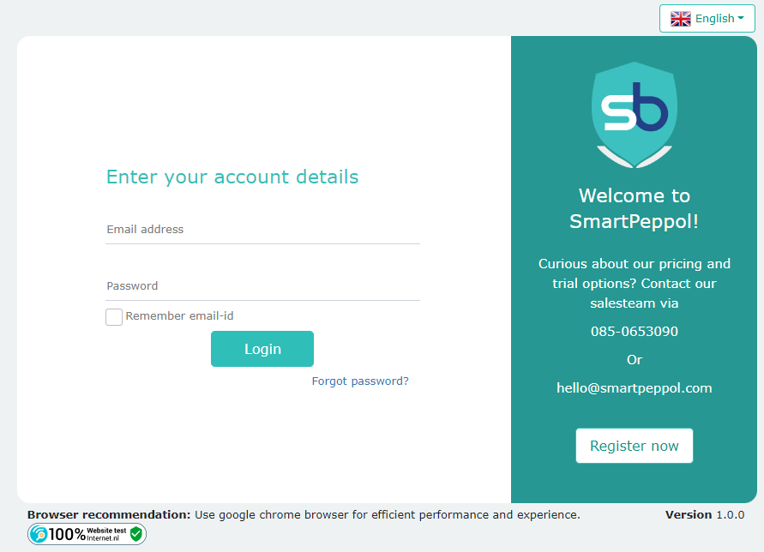

Once you have clicked on “Register Now”, you would have to fill in details on the following page.

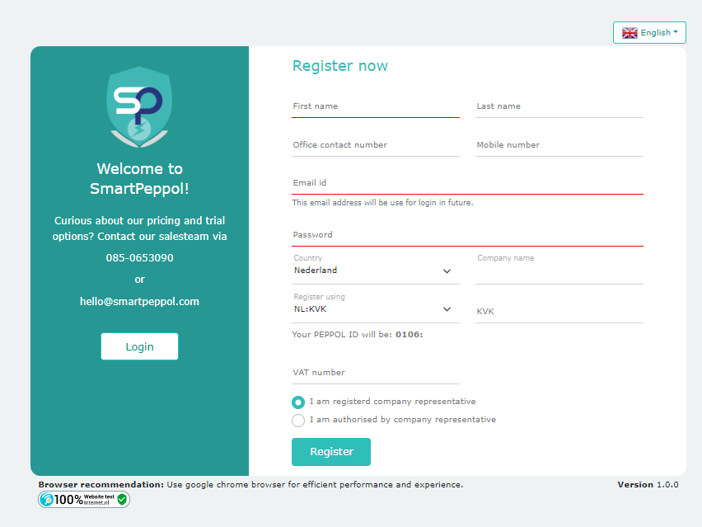

A few points to note while filling up the details are:

* The email ID and password you enter would be used as credentials for login.
* The password should be of a minimum of 8 characters and must include at least 1 uppercase letter, 1 lowercase letter, 1 special character, and 1 digit/number.
* Fields of “Country” and “Register Using” need to be selected from drop-down menus.
* “Register Using” allows you to use either KVK No or VAT No or OIN No – this would decide the PEPPOL scheme on the basis of the country.

Note: If Netherlands is selected as the country, then the VAT and KvK numbers are mandatory.

* If you chose the option of “I am authorized by company representative” – you will mandatorily have to enter your Name, Email ID, and Contact No.

Once you have entered all the details, you will have to verify your email ID (by entering the code shared on your email address) and then registration would have been successful.

Note: The registration code would only be valid for 24 hours from the time of generation.

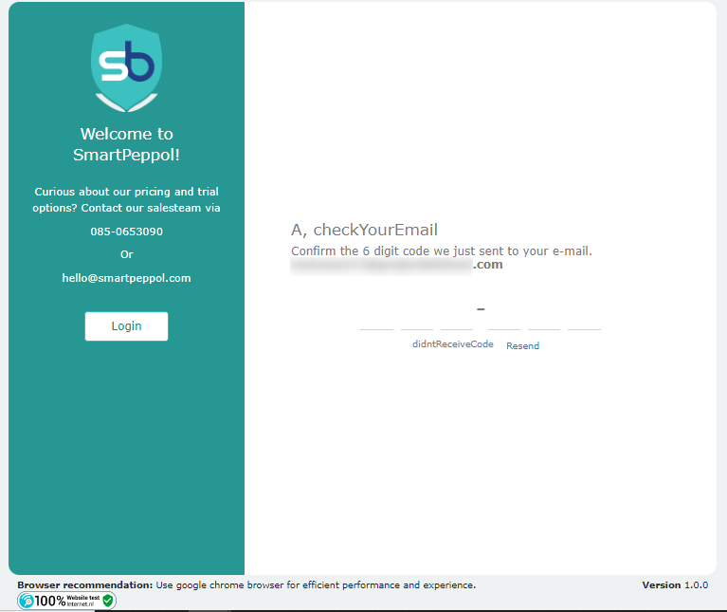

After registration is completed, we will verify your PEPPOL ID after which you can log in to the system.

**Our Portal:**

Once you have registered with us for our Smart PEPPOL services. You can log in to our portal via registered Email ID and Password.

We will first walk you around the main hamburger menu on the left and then onto our other features.

**Inbox –** The Inbox view shows our users all the documents which have been received by the organization. It shows a tabular list which contains information like - Document Number, Document Date, Document Type, PEPPOL ID of the Sender, Contact/Relation etc.

**Outbox** – The Outbox view shows information about the outbound PEPPOL documents for the organization. Right at the top, it displays the status in terms of “Queued”, “Error on PEPPOL”, “Undelivered in PEPPOL”, “Error on Email” and “Undelivered on Email” tabs.

Other information like File Name, Document Number, Document Date, Document Type, Status of export etc. are displayed too. On this page, you can select multiple documents and either “Delete” them or “Retry” sending them again by clicking on the buttons provided.

**Sent Items –** The Sent Items view shows our users all the documents which have been sent out from the organization. In addition to all the basic information about these documents, it also shows the Delivery address and Distribution mode.

**Contact** – The Contact view contains all the information and details which have been created either by receiving or sending documents from/to them. It displays the Contact No, Contact name, PEPPOL ID, Email IDs, Contact type, Sent Count, Received Count etc.

Here, we have given an option where our users can upload contacts so that these are available in the system for use. On clicking the ”Upload Contact” button, users will be able to see the current status and summary of the contacts after upload.

**Note: The Inbox, Outbox, Send Items and the Contact pages all have filters which can facilitate our users in finding a particular document via the different options (Doc date, Doc date etc.)**

**Send Documents-** This button on the bottom left corner will help you to receive (submit) documents. Users can upload ‘n’ number of documents at a time and the progress of uploading will be shown as a progress bar. The ‘Sending’ progress bar will only start once the upload section is completed.

The different counters show:

The **Total count** of documents to be uploaded or to be sent to Smart PEPPOL.

The **Upload Errors** shows the count and reason for some documents failing to be uploaded, along with a “Retry” button below.

The Sent on PEPPOL counter shows the progress of documents being sent on PEPPOL.

The Sending Error counter shows the PEPPOL errors and validation errors with the documents.

An important feature for our clients here is of the “Send in background” button. This button will allow the user to navigate to other menus once the upload is completed and sending is in progress.

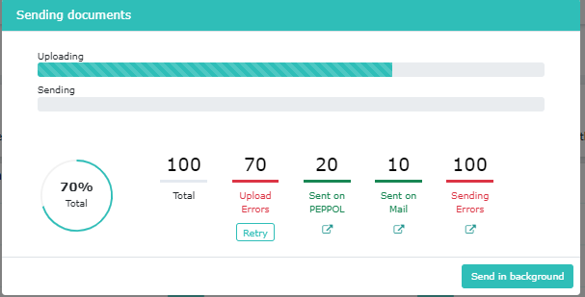

Except these functionalities and counters, our customers will also be able to manage settings for their PEPPOL Profile, General settings, Outgoing settings, and Notifications.

**The PEPPOL profile settings include:**

* Company Information.
* PEPPOL Information.
* Managing document types.

**General Settings include:**

* Auto-create Contacts toggle button.

**Outgoing settings include:**

* Auto-create PDF toggle button.
* Managing document creation for PDFs.
* Retry Sending information.
* SBDH (Standard Business Document Header) settings.
* Enable email sending (Send email if participant not found on Peppol).

The Notifications settings manage on when notifications must be sent out.

Our “My Account” section allows our users to personalize the portal according to their choice. They can choose the language in which they wish to see the portal.

Once into the “My account” tab the user can change their profile information as well as change their password.

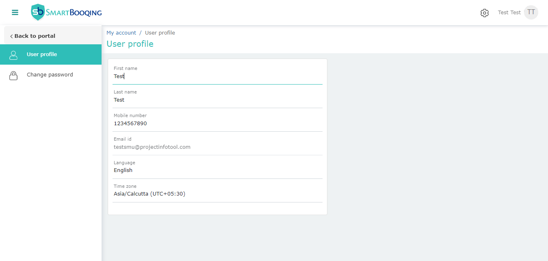

**Password Expiration Policy:**

Users can choose to enable or disable this setting. It has been introduced to reduce the risk of unauthorized people being able to access your accounts, so by changing your password periodically.

